**JOBSHEET 7**

**DYNAMIC PROGRAMMING**

**PRAKTEK**

package HitungFibonacci;

import java.math.BigInteger;

import java.util.Scanner;

/**

*

* @author FRADILA

*/

public class Praktek {

private static void tampilJudul(String identitas) {

System.out.println("Identitas : " + identitas);

System.out.println("\nHitung Fibonacci");

System.out.println("1, 1, 2, 3, 5, 8, 13, 21, ... dst.\n");

}

public static void main(String[] args)

{

String identitas = "Fradila Nur Hasanah / XRPL2 / 15";

tampilJudul(identitas);

int n = tampilInput();

BigInteger hasil = fibo(n);

tampilHasil(n, hasil);

}

private static int tampilInput() {

Scanner scanner = new Scanner(System.in);

System.out.print("Bilangan ke-: ");

int n = scanner.nextInt();

return n;

}

// method fibo untuk menghitung fibonacci

private static BigInteger fibo(int n) {

BigInteger[] hasil = new BigInteger[n];

hasil[0] = BigInteger.ONE;

hasil[1] = BigInteger.ONE;

for (int i = 2; i < n; i++) {

hasil[i] = hasil[i-1].add(hasil[i-2]);

}

return hasil[n-1];

}

private static void tampilHasil(int n, BigInteger hasil){

System.out.println("Bilangan Fibonacci ke-"+n+" : " + hasil);

}

}

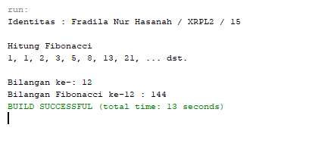

**TUGAS 1**

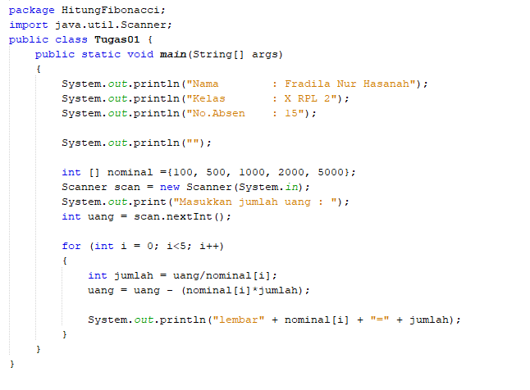

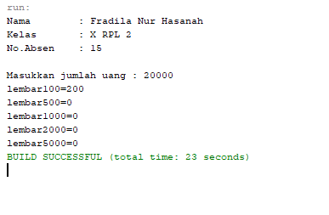

**TUGAS 2**

